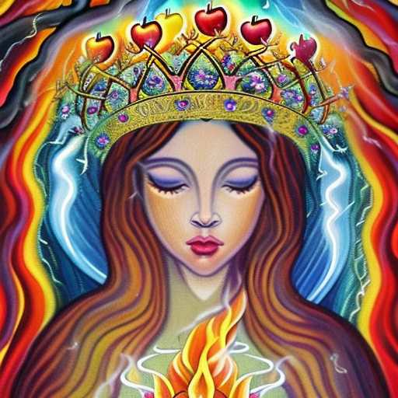
LOGOS SPARKLES ON THE WATER

Living Flames of Love
Sacred Hearts
Beautiful faces of Queens with Jeweled Crowns of Heavenly Corona
Sparkles walking upon the water
Like Eve you beckoned me with bitter apples
Until what I knew fell away
and became a branch in a Tree made of Vines of Wisdom, Life & lightning, which flows through all souls as a river of Holy Water.
Daena took my hand
She delivered me to the Immaculate Conception, who was Ever growing Beauty.
Sparks of something new in the Garden over the sun
Ezekiel & Zion
Spiritually open, sparkling eyes

